Instructions for migrating your databases to new versions. (The data in these will be permanent and able to be migrated for further releases).

1. Drop all of your current application databases: See screenshot of server explorer: this is what it looks like after I already dropped the databases. To do this, left click on the table dbo.\* and then ‘delete’ a script will get generated to run to drop the database. You can stack multiple drops in this script. You do have to drop the databases in a specific order. This order is the reverse order as that specified in InitialCreateSQL.txt. (You may or may not have this when I push my code up.) At the end, you should only have the migrations history.

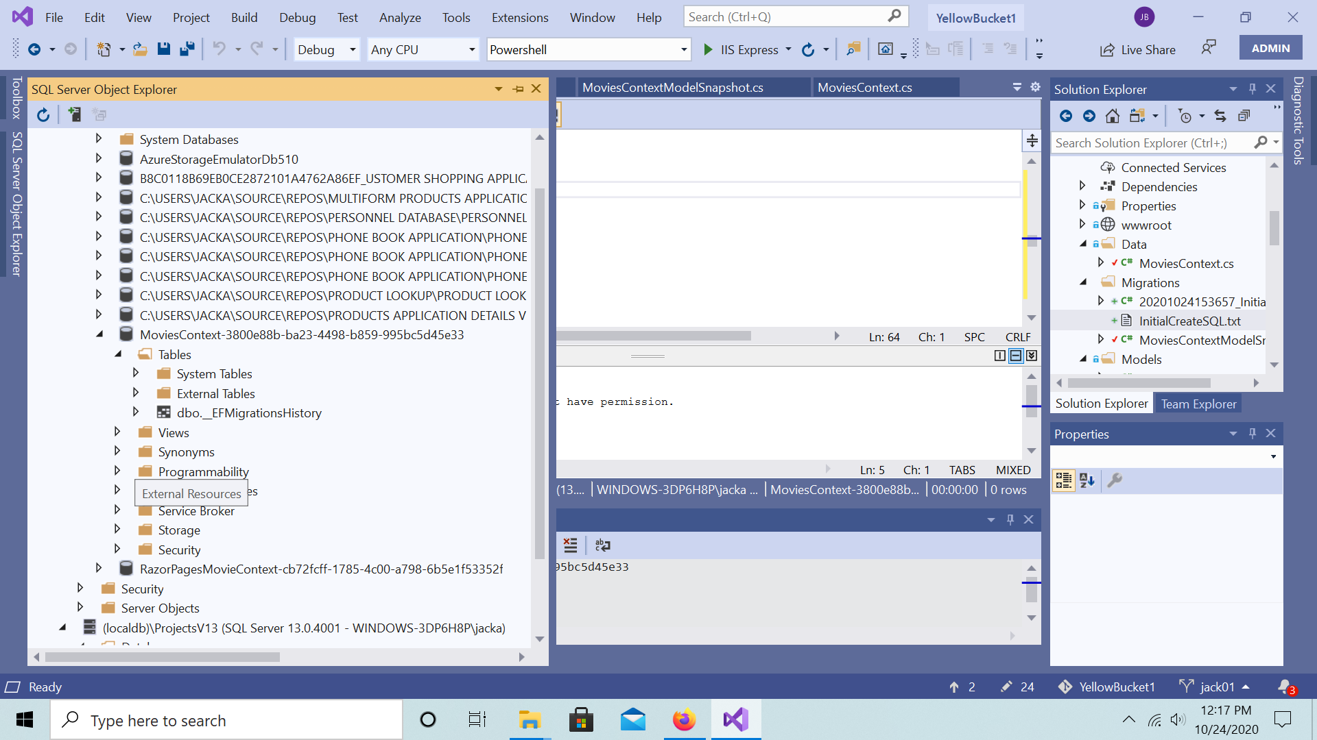

1. Delete your entire Migrations folder for YellowBucket1 – this is also in the screenshot. Don’t worry, this is not needed since it will get recreated shortly.
2. Run visual studio as an administrator (required). Then, run the new project I created called Powershell. Let powershell run until you see the message ‘press any key to continue.’ Then you can end the application. I promise there are no viruses.
3. At this point, the databases are created and your migrations folder fixed. The database side is now set up. So from here, you want to scaffold your pages again, etc. to regenerate the code for those pages with the updated databases. (Also, you can generate code for every table / model ex. Customers, Movies, Rentals, etc.). I already tested this in class last time: the trick is to delete your pages before creating them or else locking conflicts will not let you update them. (Save any of your code changes in a separate file first or copy your files first). Then, reapply your changes to the pages to continue.
4. For your convenience, I auto generated the SQL for your reference. This will be the easiest form of documentation since changes will still be occurring throughout the coming weeks.
5. For further migrations, I think all you have to do is run the Powershell application/project in order to update your databases. (I think you would only have to change your pages again in certain situations).